- Cheaper mortgage deals have driven a strong recovery in UK housing demand in recent months. Unlike the short-lived upturn in activity of early-2023, this recovery looks more durable. But much will depend on whether the Monetary Policy Committee fulfils market expectations of looser monetary policy this year.
- Survey data suggests that wage and price inflation continue to cool, with competitive pressures beginning to squeeze margins. If mirrored in official series, this should allow the MPC to start cutting rates from June. But equally, the cooling in underlying price pressures is sufficiently slow that the MPC is likely to take a cautious approach to the pace of subsequent cuts.
Though the reaction of house prices to the 2022-2023 rate hiking cycle was surprisingly muted, housing market activity slowed to a crawl. But since markets switched their attention in the second half of last year to future rate cuts, cheaper funding costs led lenders to cut their mortgage rates, and demand has started to strengthen again. That recovery gained pace in February, with mortgage approvals rising above 60,000 for the first time since September 2022.
The strength of the link between approvals and quoted mortgage rates in the intervening period is striking (Chart 1). Initially, the infamous Truss-Kwarteng mini-Budget triggered a steep rise in swap rates which quickly fed through to higher mortgage rates, causing demand to slump. The reversal of most of the Truss policies brought a period of relative calm, with mortgage rates falling back and activity beginning to recover. But this recovery was quickly snuffed out by last spring's heightened concerns about inflation persistence, which triggered a second spike in mortgage rates and renewed slump in activity.
The latest turnaround appears more durable. Average fixed rate deals have fallen by between 130bps-145bps since last summer, and in response mortgage approvals have risen for five successive months. Though swap rates rose in the early weeks of this year, as markets reversed some of their pre-Christmas dovishness, so far the impact on mortgage rates has been relatively muted.
Chart 1: Mortgage activity has strengthened in response to a sharp fall in interest rates
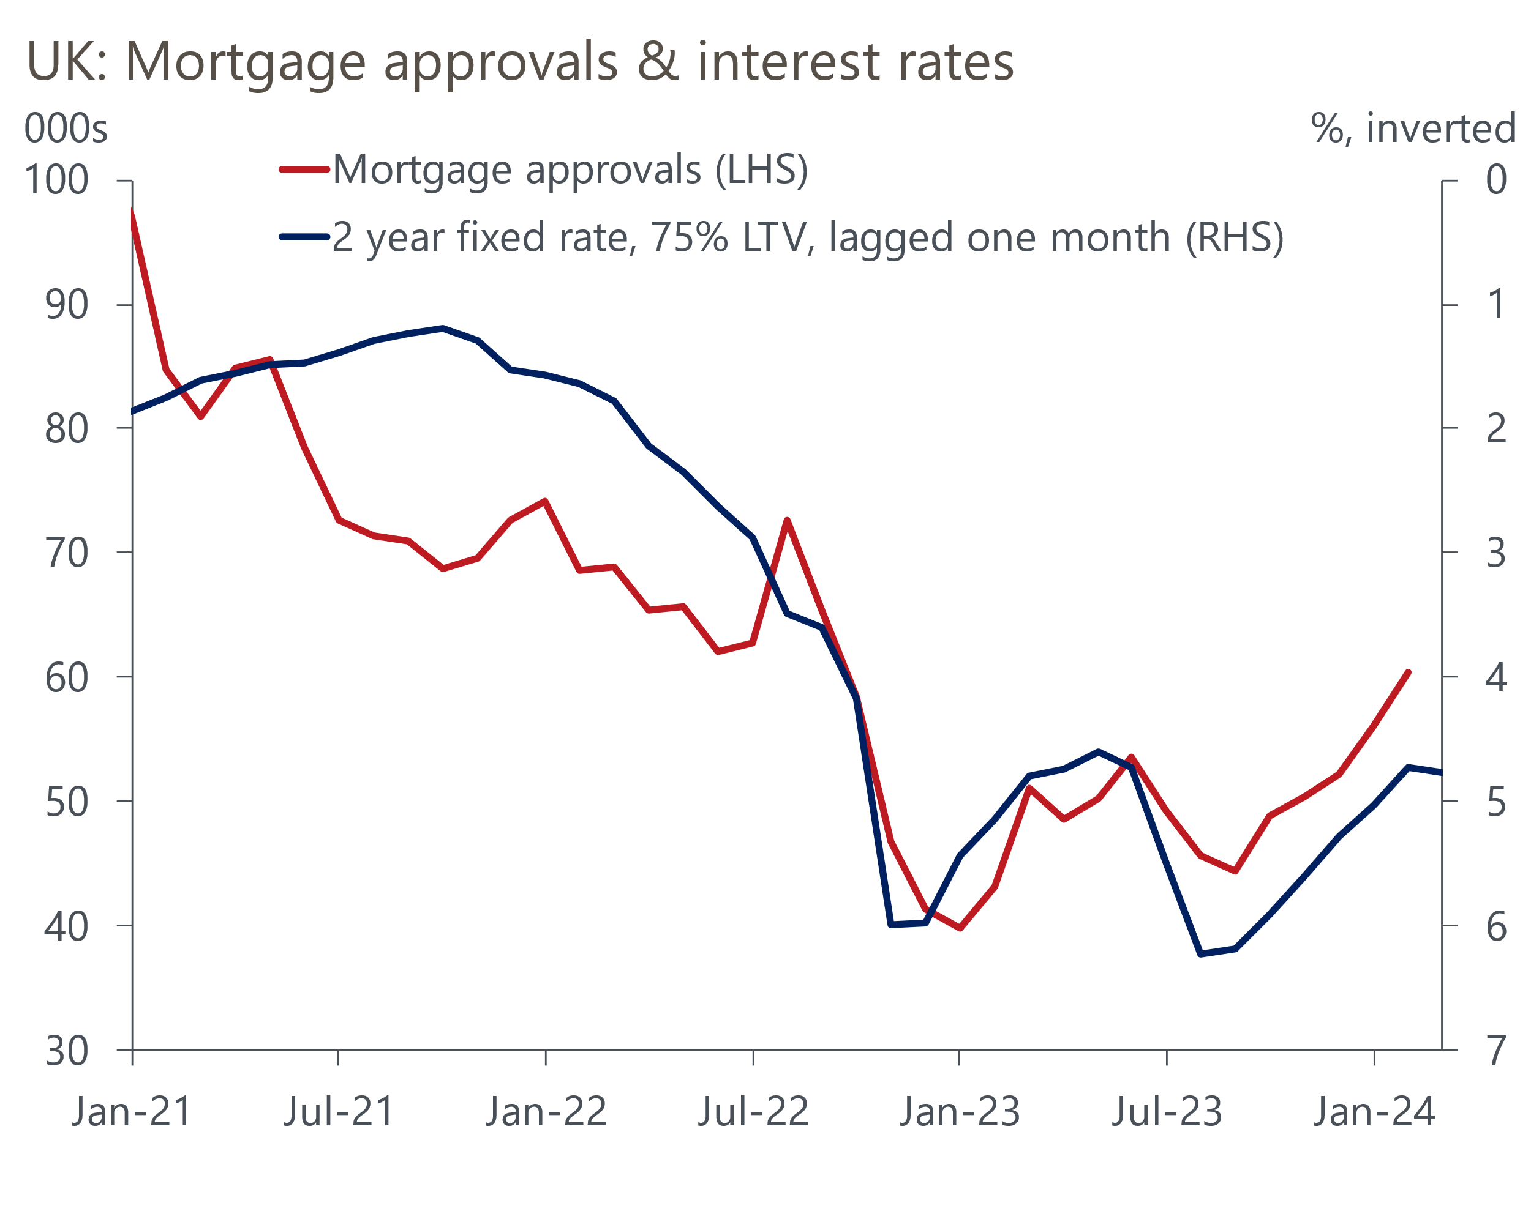
Source: Haver Analytics

Where mortgage rates go from here will be heavily influenced by whether the Monetary Policy Committee satisfies markets' expectations of rate cuts. Having been very volatile over the past year, market pricing has been much more stable in recent weeks, with a consensus forming around a first cut in the summer and two further 25bps cuts before the end of the year.
The MPC's recent mood music has been consistent with this profile. But the data on core inflation and pay growth over the next few months will be key, and this week's business surveys offered reason to think that the coming official data will be supportive of rate cuts. The MPC places particular store on the Bank of England's Decision Maker Panel, and the March survey reported further falls in the backward- and forward-looking results for both prices and wages (Chart 2).
Chart 2: The BoE's flagship survey suggests wage and price pressures continue to cool
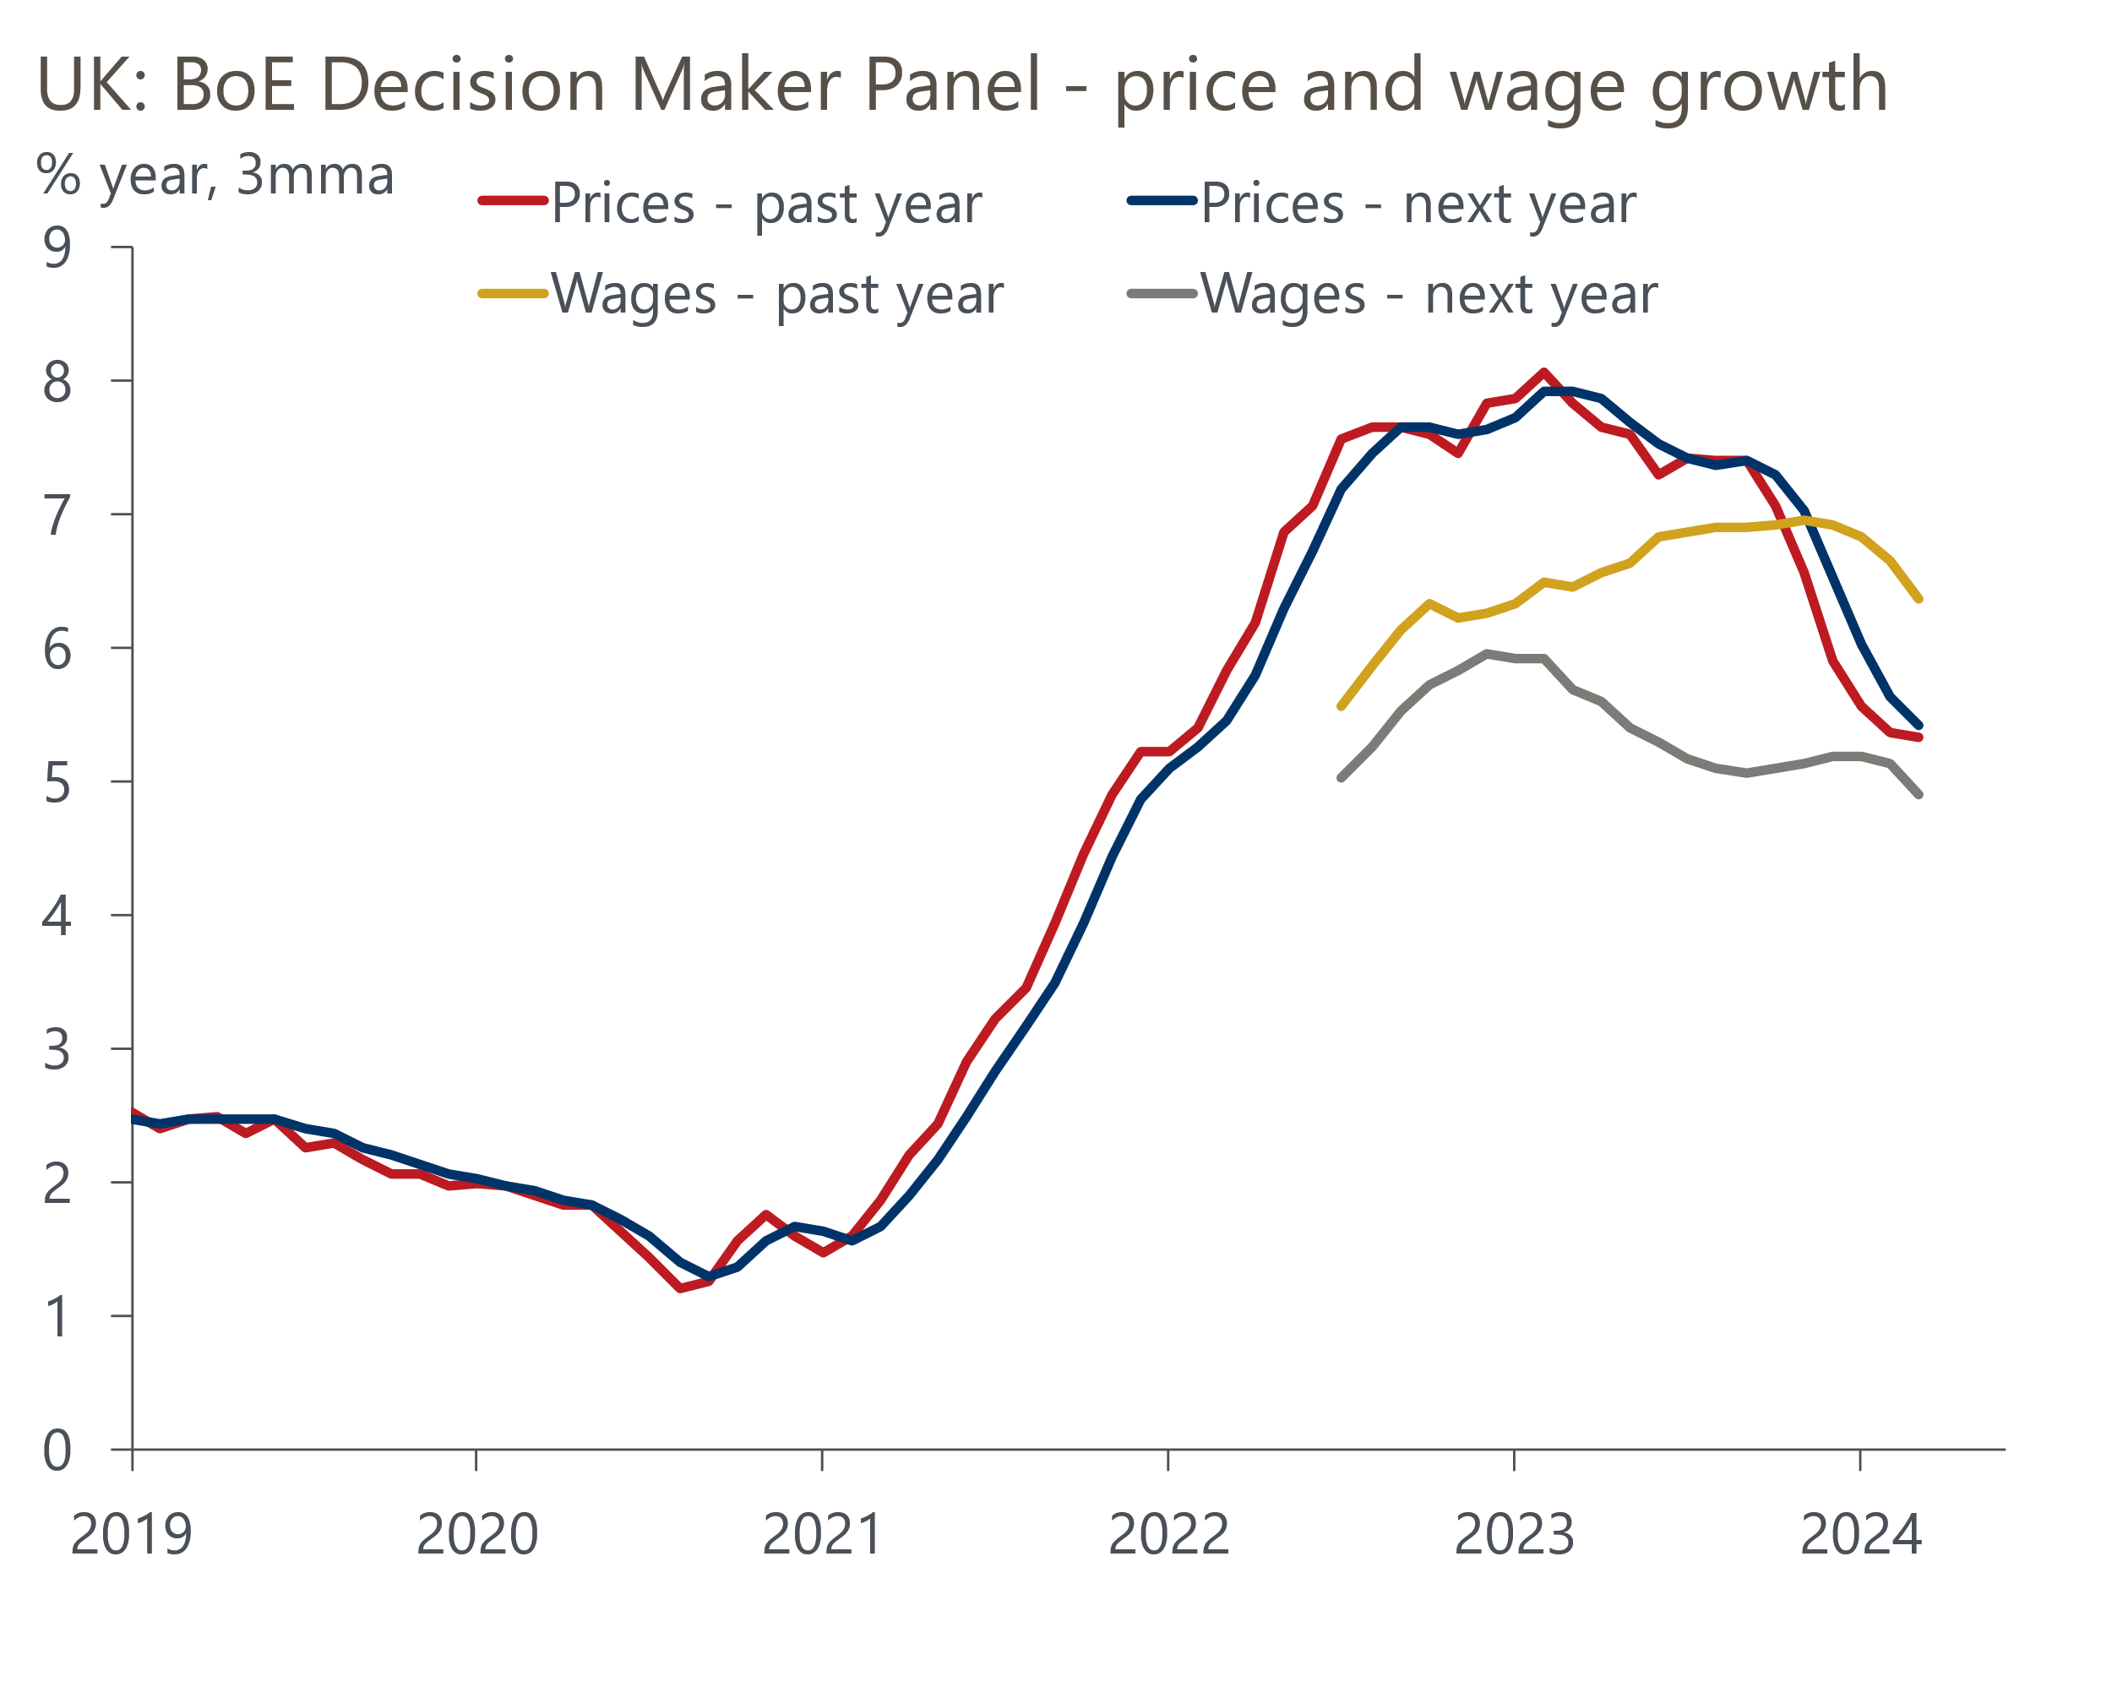
Source: Haver Analytics
While the DMP results suggest pay and price pressures remain stronger than would be consistent with achieving the inflation target on a sustained basis, the MPC has suggested that this would not be a bar to loosening, as policy would still be very restrictive even after the MPC has started to cut rates. The MPC will also have been heartened by the results of March's S&P Global services survey. Though respondents reported that firm wage pressures were keeping input cost inflation elevated, the strength of competitive pressures meant that output price inflation dropped to a six-month low.
So we remain happy with our call that the first rate cut will come in June, and that two more 25bps cuts will follow before the end of the year. Given this scenario is broadly consistent with market pricing, it should mean that swap rates, and therefore mortgage rates, remain close to current levels in the next few months. This, in turn, should limit the risk that the recent recovery in mortgage approvals reverses.
That said, the scale of the rebound in housing demand is likely to be capped by poor affordability. Nationwide and Halifax reported that house prices fell by 0.2% and 1% respectively in March. But the monthly series from the lenders are notoriously volatile and March's falls followed a series of stronger outturns. It seems likely that the correction in prices is largely over. But with our mortgage affordability model suggesting that house prices are still 13% overvalued, and supply very tight, the pool of potential buyers remains limited.
The week's data also reinforced our confidence that a broader recovery in activity is underway. Though the services PMI slipped back, the manufacturing equivalent returned to expansionary territory for the first time in 20 months, underpinned by stronger trends in output and new orders. Similarly, another increase in gross unsecured lending in February offered hope that households are shedding the cautious approach of the past year. Next week's GDP release for February will provide a better steer. But as things stand, we think the economy enjoyed a solid rebound in activity in Q1, and expect that to mark the beginning of a sustained, consumer-led, recovery.

The week ahead
Next week's only major release is the GDP data for February. January saw output increase by 0.2% m/m, following a weaker patch in late 2023. While this was consistent with our view that 2024 will see a sustained recovery in activity, some of the underlying detail of the January release suggests it might be hard to post another m/m increase in February.
There was a strong rise in health output in January, despite a substantial increase in the number of working days lost to strikes. So though there was less strike disruption in February, it may not translate into stronger output. January's increase in GDP was also heavily reliant on strong outturns for the construction and distribution sectors. But timelier indicators and February's very wet weather suggest construction output probably dropped back that month. Meanwhile retail sales were unchanged in February.
On balance, we think GDP is likely to have been flat in February.
Table 1: Week ahead calendar
Date | Events | Period | Measure | Unit | Previous | Forecast
Apr 12 | GDP | Feb | m/m | % | 0.2 | 0.0
Apr 12 | GDP | Feb | 3m/3m | % | -0.1 | 0.1
Apr 12 | Index of services | Feb | m/m | % | 0.2 | 0.1
Apr 12 | Index of services | Feb | 3m/3m | % | 0.0 | 0.1
Apr 12 | Manufacturing output | Feb | m/m | % | 0.0 | 0.0
Apr 12 | Manufacturing output | Feb | y/y | % | 2.0 | 1.6
Apr 12 | Industrial production | Feb | m/m | % | -0.2 | 0.3
Apr 12 | Industrial production | Feb | y/y | % | 0.5 | 0.6
Apr 12 | Construction output | Feb | m/m | % | 1.1 | -0.9
Apr 12 | Construction output | Feb | y/y | % | 0.7 | -1.0
Apr 12 | UK trade | Feb | Trade balance | £bn | -3.1 | -3.1
Apr 12 | UK trade | Feb | Visible balance | £bn | -14.5 | -14.5
Source: Oxford Economics

Key forecasts
Table 2: UK forecast overview
(Annual percentage changes unless specified)
 | 2022 | 2023 | 2024 | 2025 | 2026 | 2027
GDP | 4.3 | 0.1 | 0.5 | 2.0 | 2.0 | 1.6
Private consumption | 4.8 | 0.2 | 0.9 | 2.6 | 2.2 | 1.6
Fixed investment | 8.0 | 2.2 | -2.8 | 1.1 | 2.8 | 2.1
Government consumption | 2.3 | 0.5 | 4.1 | 2.2 | 1.5 | 1.5
Exports of goods and services | 9.0 | -0.5 | -0.5 | 2.7 | 2.4 | 1.7
Imports of goods and services | 14.6 | -1.5 | 2.2 | 3.5 | 2.9 | 1.9
Industrial Production | -3.5 | -0.3 | 0.1 | 0.9 | 1.5 | 1.1
Consumer prices | 9.1 | 7.3 | 2.1 | 2.1 | 2.3 | 2.2
Unemployment rate (%) | 3.9 | 4.0 | 4.0 | 3.9 | 3.8 | 3.7
Current a/c balance (% of GDP) | -3.1 | -3.3 | -3.0 | -2.9 | -3.0 | -2.9
Government balance (% of GDP) | 4.4 | 5.0 | 3.5 | 3.0 | 2.2 | 1.5
Cen. bank policy rate (%, EOP) | 3.50 | 5.25 | 4.50 | 3.50 | 2.50 | 2.00
10yr govt. bond yield (%, EOP) | 3.67 | 3.54 | 3.85 | 3.51 | 3.05 | 2.85
Exchange rate (US$ per £, EOP) | 1.20 | 1.27 | 1.27 | 1.27 | 1.28 | 1.30
Exchange rate (euro per £, EOP) | 1.13 | 1.15 | 1.16 | 1.15 | 1.15 | 1.14
Source: Oxford Economics
Table 3: Quarterly forecasts for the UK
 | 2024 |  |  |  | 2025
 | Q1 | Q2 | Q3 | Q4 | Q1 | Q2 | Q3 | Q4
GDP (% year) | -0.1 | 0.2 | 0.7 | 1.5 | 1.7 | 2.0 | 2.1 | 2.2
CPI inflation (% year) | 3.4 | 1.7 | 1.6 | 1.8 | 1.9 | 1.9 | 2.3 | 2.3
Bank Rate (%, EOP) | 5.25 | 5.00 | 4.75 | 4.50 | 4.25 | 4.00 | 3.75 | 3.50
10yr gilt yield (%, EOP) | 3.95 | 3.95 | 3.91 | 3.85 | 3.78 | 3.70 | 3.61 | 3.51
US$ per £ (EOP) | 1.26 | 1.27 | 1.27 | 1.27 | 1.27 | 1.27 | 1.27 | 1.27
Euro per £ (EOP) | 1.17 | 1.16 | 1.16 | 1.16 | 1.16 | 1.16 | 1.15 | 1.15
Source: Oxford Economics

Latest Country Economic Forecast:
March 18, 2024

Recent publications

Data Insights
Lower services PMI still points to healthy activity growth in Q1
Manufacturing output returned to growth in March
Recovery in mortgage demand continues
National accounts confirm the weak performance over H2 2023
February's retail data consolidates January's rebound

Research Briefings
The MPC and rates - preparing to descend Table Mountain
MPC remains on track for a June rate cut
MPC preview – Caution is the name of the game
Rethinking the UK’s fiscal rules is a key to unlock growth
Is 'immaculate disinflation' likely?

Contacts

Oxford Economics' UK team
- Andrew Goodwin - Chief UK Economist - agoodwin@oxfordeconomics.com
- Edward Allenby - UK Economist - eallenby@oxfordeconomics.com

